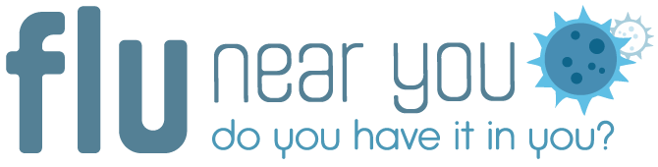

Background

Flu Near You is a crowdsourced disease surveillance tool that asks users to anonymously report their symptoms (or lack thereof) of influenza-like illness (ILI) each Monday morning. The project asks volunteers to spend a few seconds each week contributing to the information on flu-related trends so that both public health officials and the general public can track the spread of influenza. Volunteers can enroll online at www.flunearyou.org or via mobile applications for iOS and Android. Users can report for other members of their household.

Getting Started with Flu Near You

Benefits

- Flu Near You (FNY) is a free, easily accessible program for which data can be made available to local or state health departments via a private Flu Near You dashboard.
- FNY has the benefit of potentially reaching populations affected by ILI that are not otherwise represented in existing surveillance programs— the non-medically attended population. Non-medically attended symptom data potentially provide representation of those that don’t seek health care because of cost, or have low SES. The use of smartphones to collect ILI data may also reach those in low SES settings where smartphones are the sole source of Internet access.
- Because FNY is actively collecting data on people who are ill and may not have presented at a health care provider, it has the potential to act as an early signal of community transmission.
- FNY has the potential to be a community outreach & messaging tool in the event of a public health emergency.
- Although FNY was designed to detect influenza-like illness, it has the potential to identify other syndromes and clusters of illness.
- FNY collects basic influenza vaccination data, acts as a reminder to get annual vaccination, and has a tool to locate available vaccinations near you.
- A public health dashboard has been developed for epidemiologists and other public health agency staff to provide access to aggregate, zip code-level symptom reporting data. Health agency personnel can request access to this dashboard at: http://dashboard.flunearyou.org/#/access_request
- Data management and analysis templates have been developed for epidemiologists or others familiar with SAS, the template code can be adapted to your jurisdiction to for use in your own formatted graphs and tables. The dashboard gives a snapshot of activity by providing graphs directly on website, and can be customized your zip codes of interest.

Recruitment & Participation

- Participation in Flu Near You is voluntary and can serve as an opportunity to engage your community with flu awareness and prevention activities
- Flu Near You data in a particular area can be enriched by growth in community participation resulting from outreach and education activities
- May be potentially used as a tool for Public Health Accreditation Board activities
- FNY has potential to reach vulnerable and/or underserved populations
- Enrollment Pathways
  - FNY users can enroll and report for their household members
  - Social media is an effective way to recruit; the FNY Facebook and Twitter accounts can be leveraged for messaging content
  - FNY links or promos can be added to ongoing messaging and newsletters
  - FNY information can be added to presentations aimed at providers and other key stakeholders.

Limitations to the Data

- It is important for public health staff to remember that Flu Near You (FNY) data may not be representative of the general population.
- Participants in the Flu Near You system represent a different segment of the population than traditional influenza surveillance systems where individuals must seek medical care in order to be included. Participants in Flu Near You may not be medically attended for reported illnesses.
- Based on a nationwide analysis conducted for the 2012-2014 time period, known biases in the Flu Near You population include:
  - generally higher influenza vaccination rates versus the general population
  - a participant population that is skewed towards higher socio-economic status versus the general population, as measured by the Human Development Index.
  - FNY participants tend to include an overrepresentation of individuals over 50 years old and underrepresent individuals under 30, relative to the general U.S. population.
  - FNY participants are also more likely to be female.
  - FNY crowdsources reports directly from participants; these reports are not validated by an external source.

